#### How to Upload an Attachment

[Echoes - Land Management](https://echoes-platform.eu/app/main/map-view)

11 Steps

Go to <https://echoes-platform.eu/>

1 - Opening the Attachments

Click on 'Attachments' button in the sites details section.

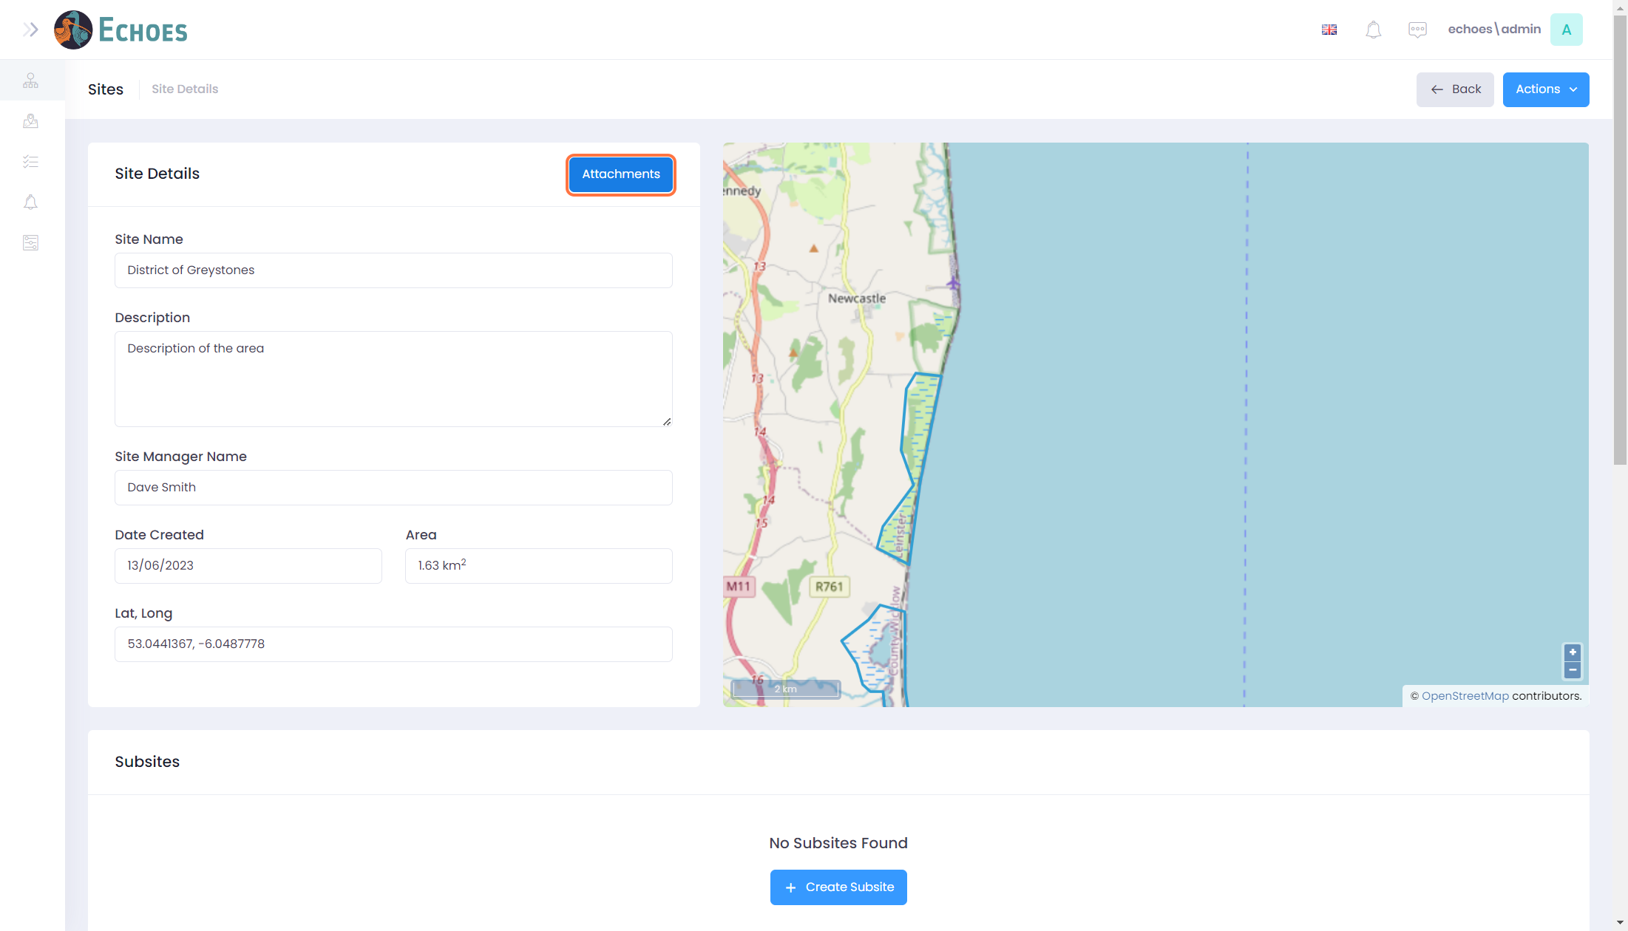

2 - Add Attachment

You will now see the open Attachments component. There are 3 tabs, Images, Videos and Documents. Any attachment you add will be automatically added to the correct section.

To add an attachment from your device, click on the 'Browse Files' button.

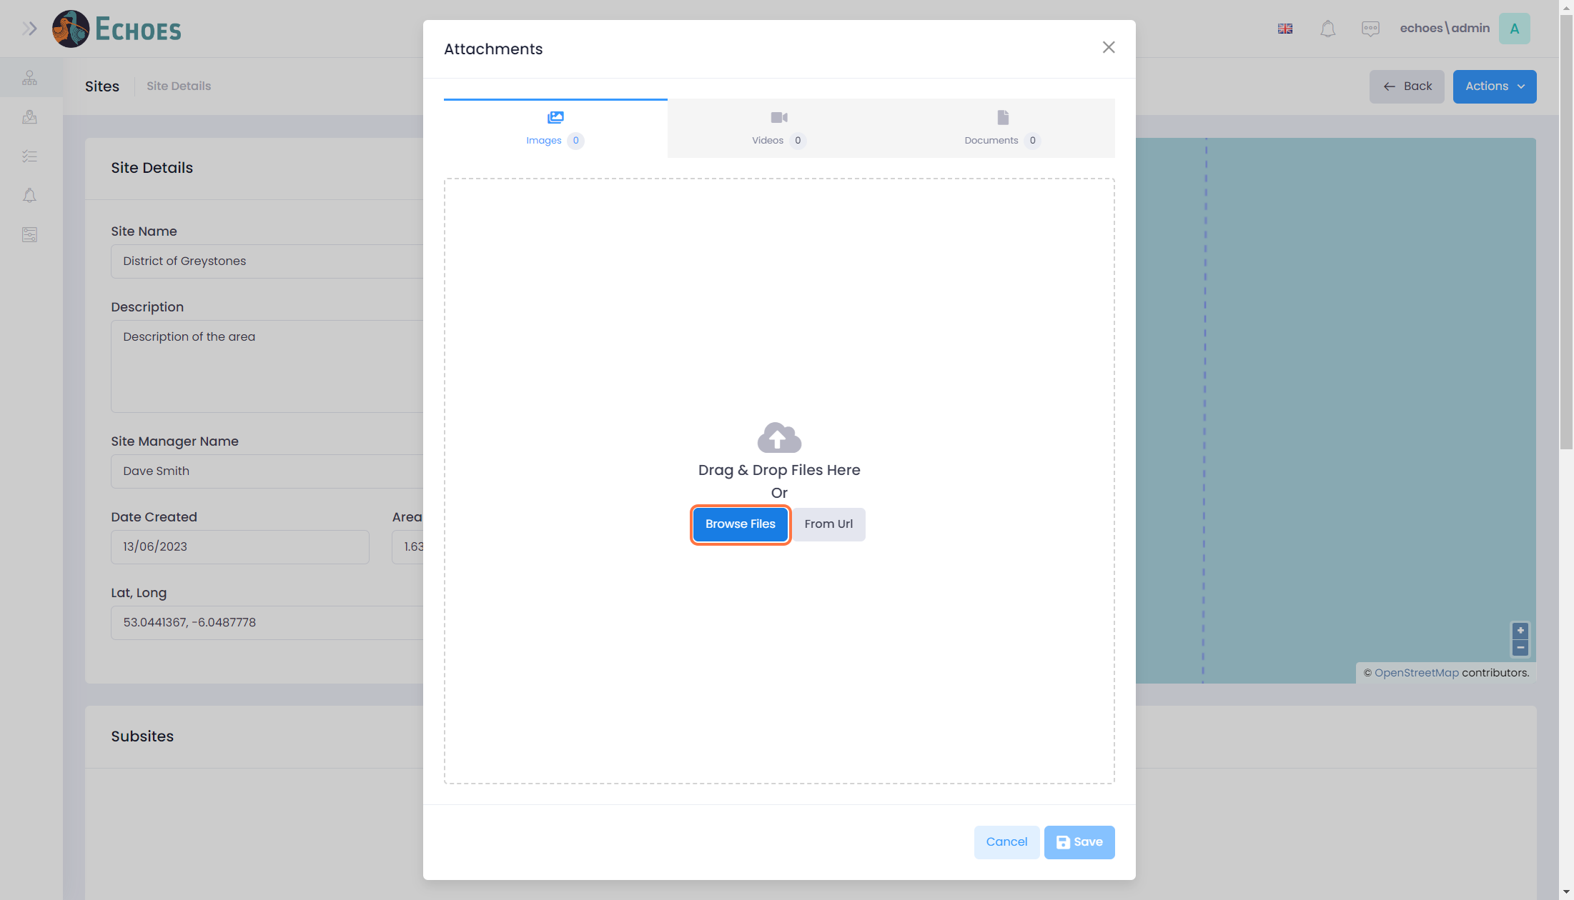

3 - Image added

Once you have chosen the attachment from your device, this will then show up in the relevant section. For this example, it is an image. Clicking on the thumbnail image will open the image full screen in a new tab.

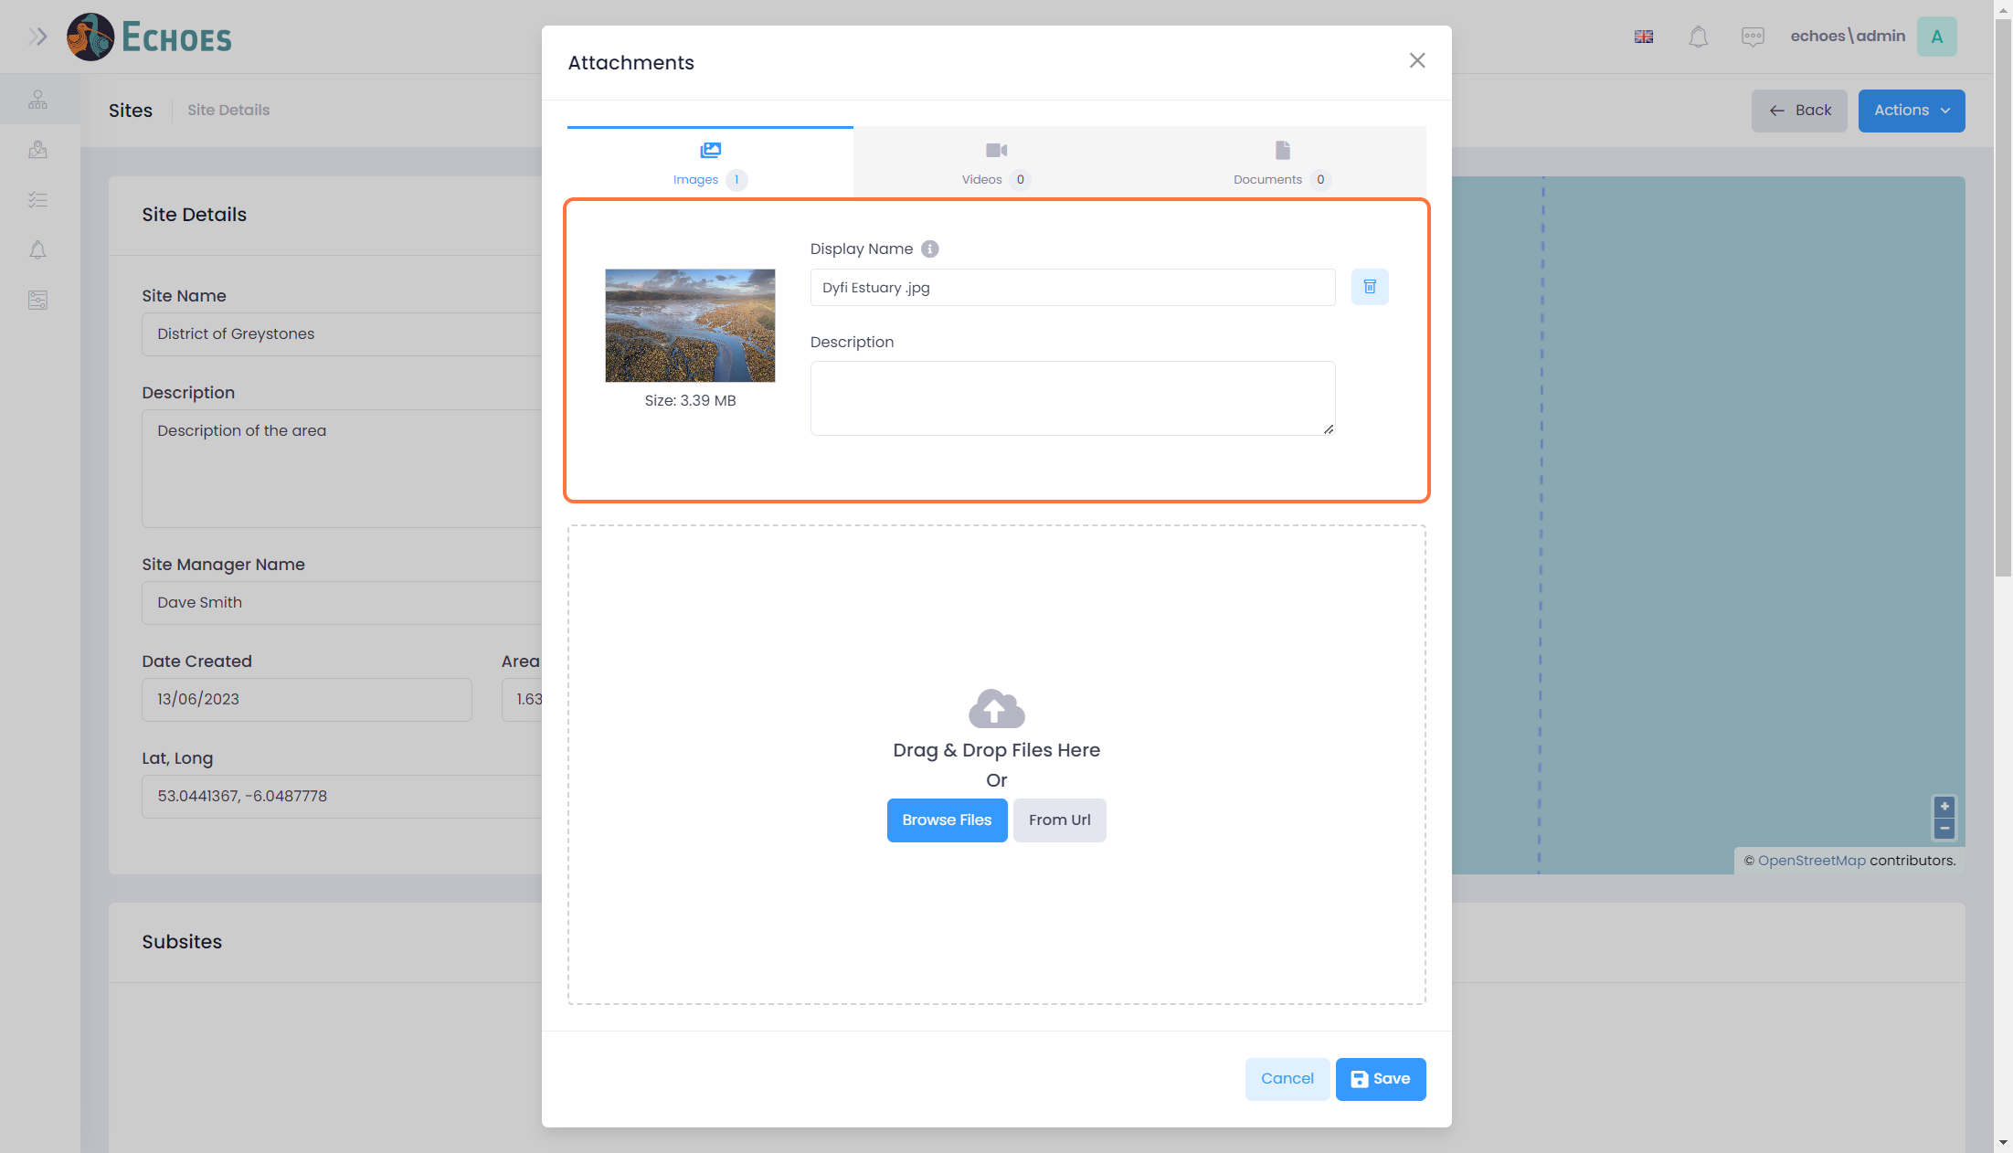

4 - Changing the display name

You can change the Display name of the attachment you have added without worrying that this will break a link if the default name is the file name. You can also add a description if needed.

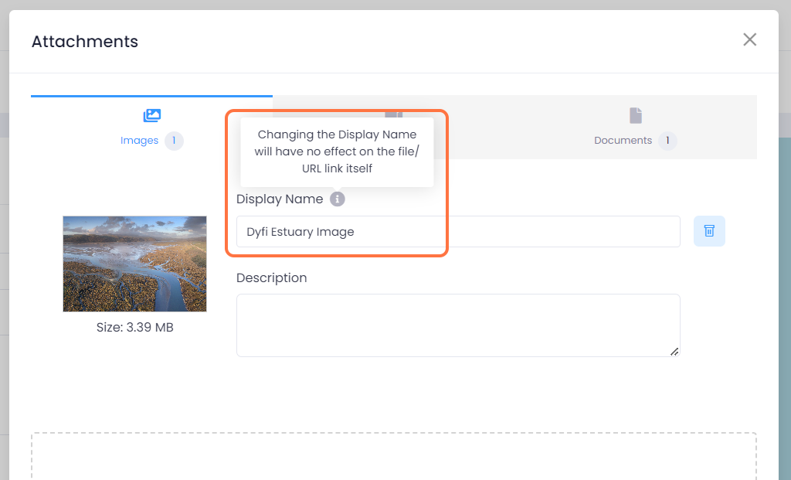

5 - Adding attachment from a URL

You can click the 'From Url' button to add a link to a URL.

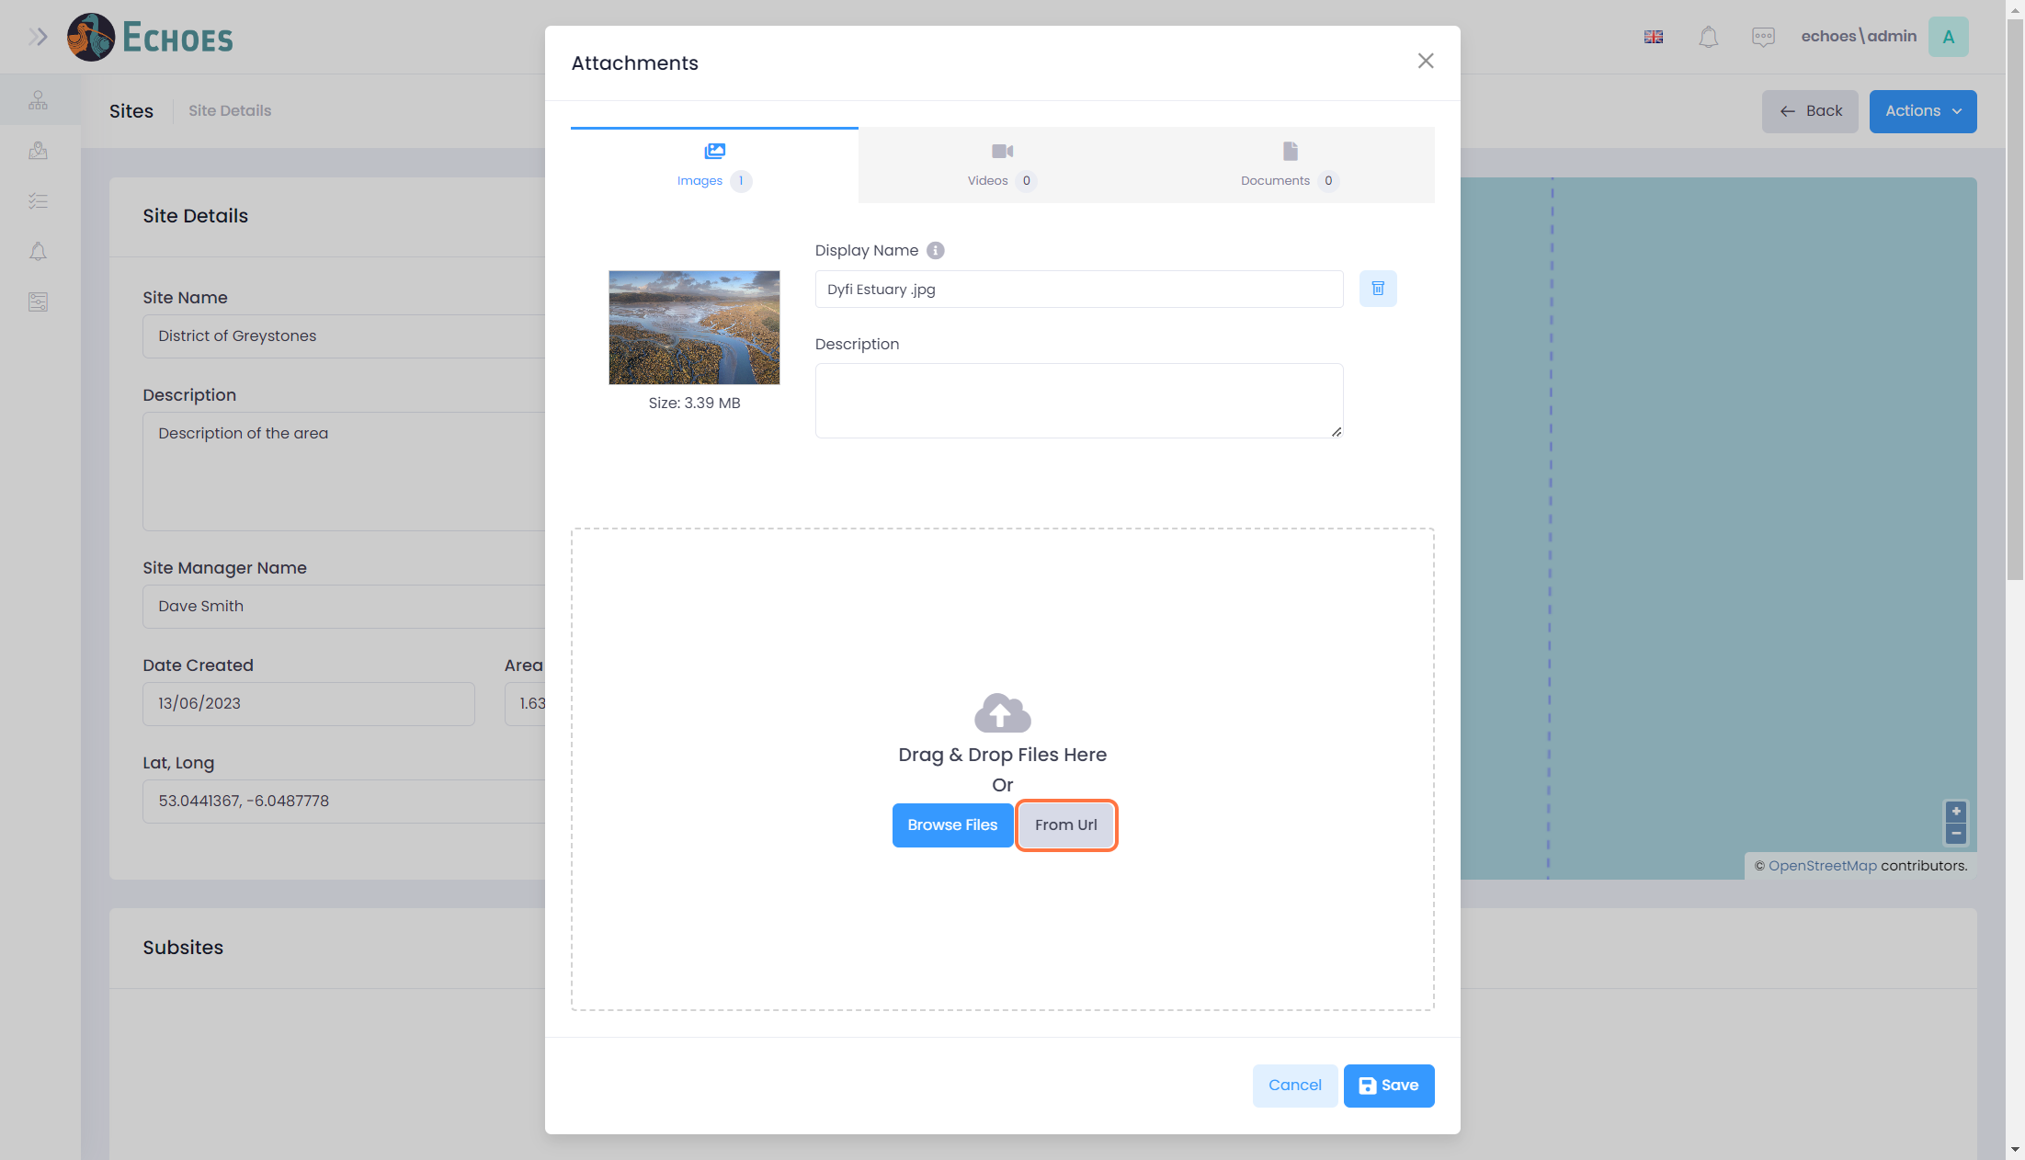

6 - YouTube Example

For example, below a YouTube URL has been added, this will then link to that page from the attachment's component. Click 'OK' to add the link.

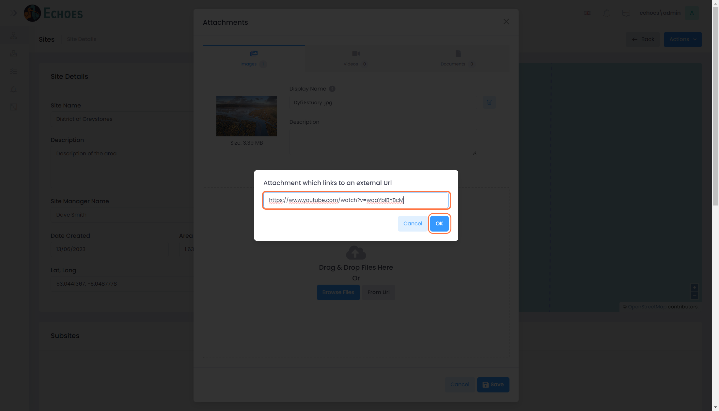

7 - Video Example

As you can see, the YouTube video has been added to the Videos tab. Again, do not worry about changing the Display name, this will not break the link to the URL. You can also add a description if needed.

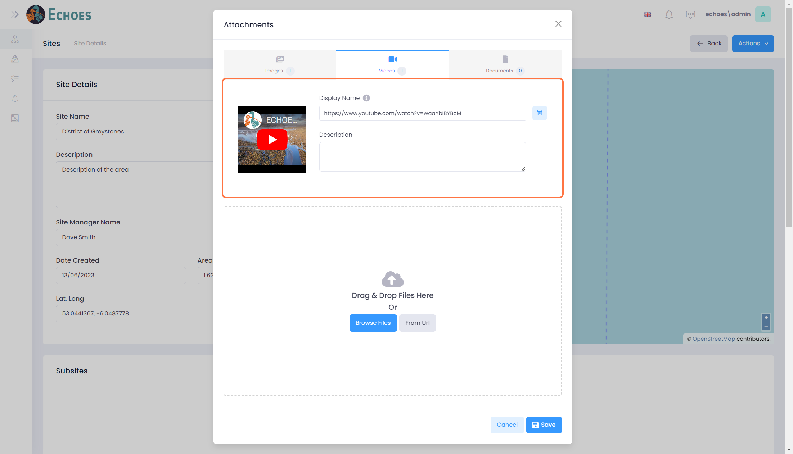

8 - Adding Documents.

To add an attachment from your device, click on the 'Browse Files' button.

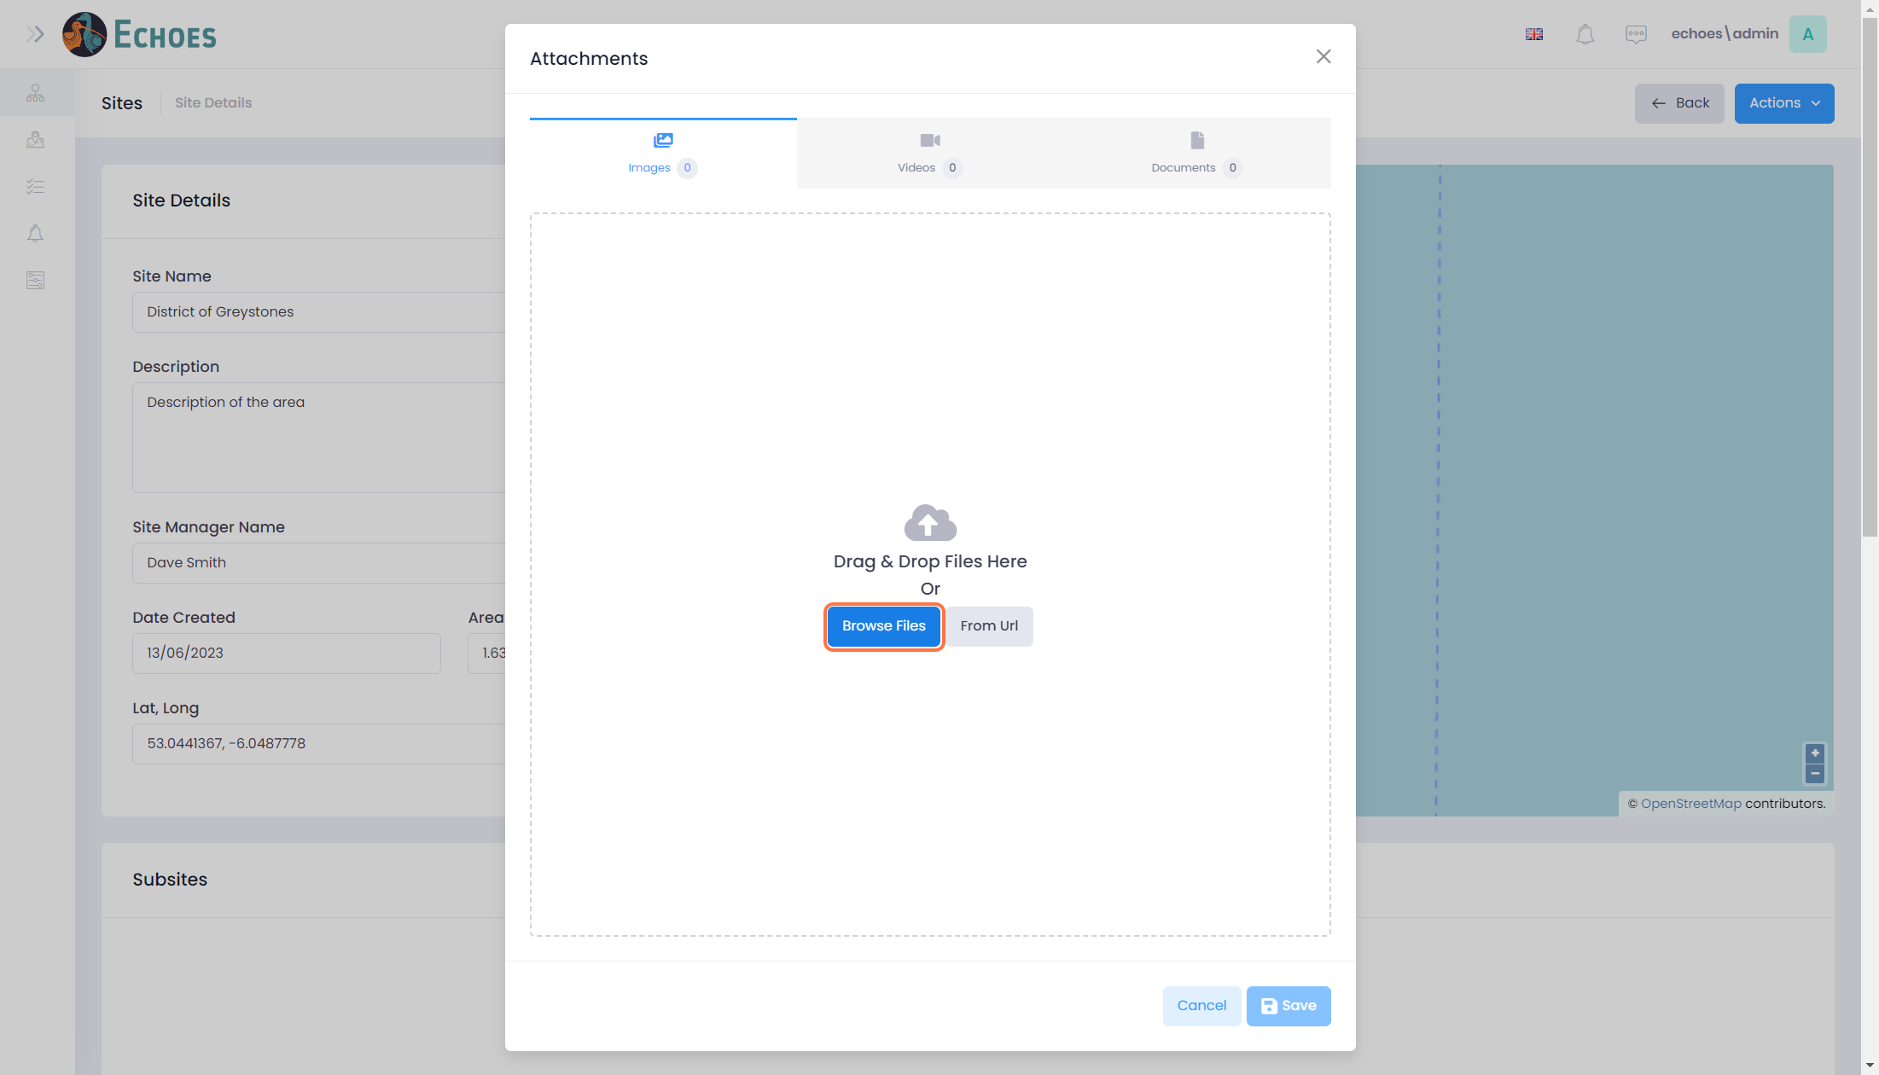

9 - Document Example

Once you have chosen your attachment from your device, you can see that it has been added to the 'Documents' tab. You can change the Display name or add a description if needed.

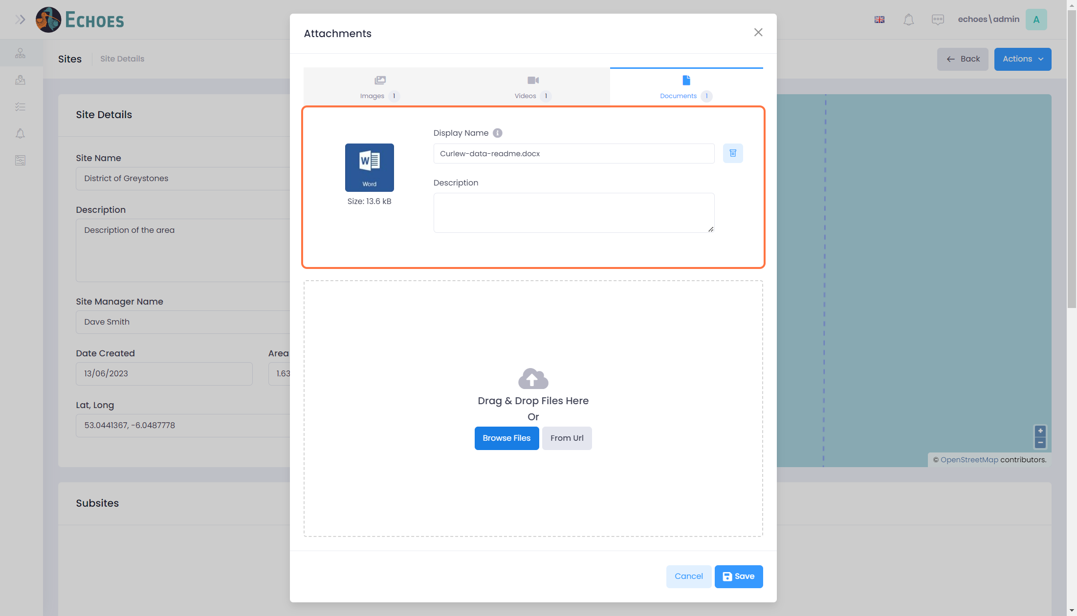

10 - Saving the Attachments.

Once you are happy with the attachments you have uploaded, you can click the 'Save' button.

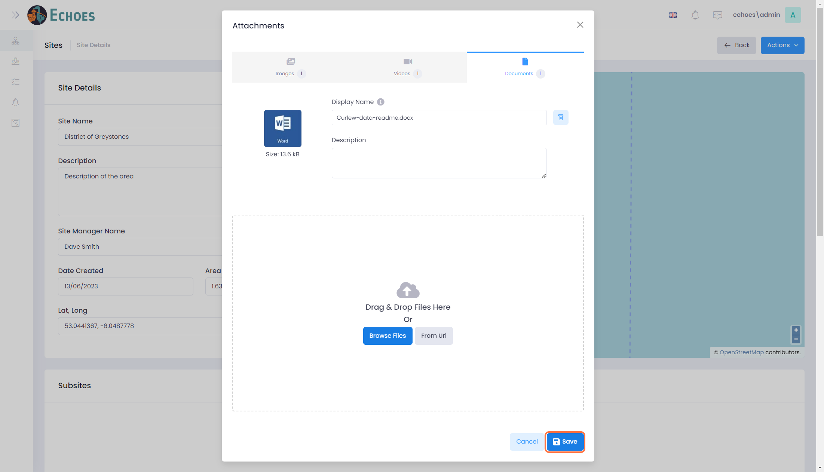

11 - Viewing the Attachment in the Data Table

As well as seeing the attachments in the attachment's component, you can also see them in the Attachments section within the sites details page.

